AUTOMATED LANGUAGE AND COMPUTING

ASSIGNMENT QUESTIONS

BRANCH:AI&ML SEM:III

1. a)List and explain the components of finite state automata

b)Summarize the closure properties of regular language

1. Draw finite automata that accepts a string which starts with ‘1’ and ends with ‘0’,

∑ = {0, 1}

1. Design DFA which accepts even number of 0’s over {0,1}
2. Design DFA which accepts language L = {100,101}
3. Design DFA for the following over {0, 1}. (R13 - December, 2017)
4. All string containing not more than three 0’s.
5. All strings that has at least two occurrences of 1 between any two occurrences of 0.
6. Construct an NFA equivalent to the regular expression 1\*0+1101 and (0+1)\*.
7. Minimize the following automata.

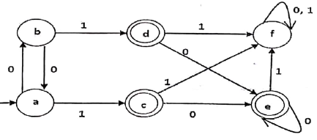

1. Convert the following NFA to DFA.

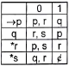

1. a)Write and explain the properties of regular sets

b) Obtain the regular expression to accept strings of a’s, b’s and c’s such that fourth symbol from right is ‘a’ and ends with ‘b’

1. a)For the grammar E → E+E, E→E\*E, E→id, construct a parse tree for the string id\*id\*id+id.

b)Discuss the closure properties of Context free languages